**Tutorial 1: Creating your first Vue 3 project**

Vue can be used in different ways:

* Control the whole website.
* Create a Single page application.
* Create standalone widgets which control certain parts of a web page.

We will be creating standalone widgets in the upcoming exercise.

**Step 1:** Create an HTML file called “**index.html**” and set it up to have the **HTML tag**, **head tag** and the **body tag**.

Look at the example below.

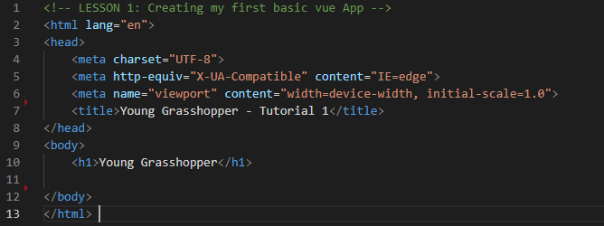

**Step 2:** Add Vue **CDN** link to the **head tag**.

Go to the [**Vue Documentation**](https://v3.vuejs.org/guide/installation.html#vue-devtools" ) to grab the **CDN** link for the Vue Library.

**@next** allows us to use the latest version of Vue

Change **next** to **3.0.2** because this is the version release at the time this document was created. For the rest of the tutorial we want to make sure that everything will behave exactly the same.

<script src="https://unpkg.com/vue@3.0.2"></script>

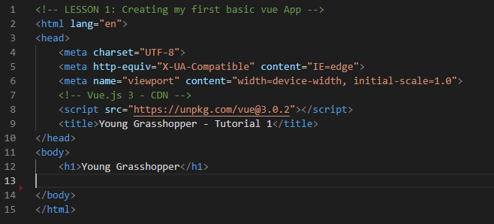Paste the CDN in the head tag. Look at the example below (**line 8**).

**Step 3:** Create a JavaScript file called “**app.js**” and link the script to the HTML page at the bottom of the body tag.

Look at example below (**line 14**).

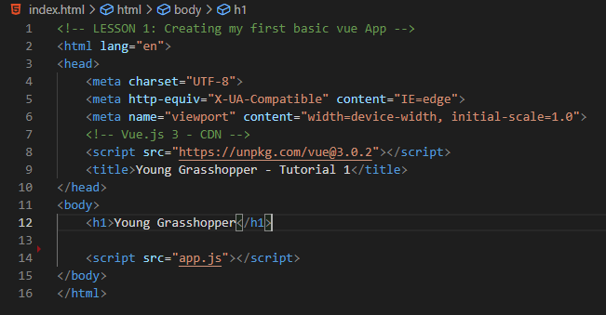

**Step 4:** Create Vue instance in the **app.js** file and mount it to a div element in the **index.html** file.

In the **app.js** file, using the Vue library set in the HTML, we are able to access the Vue object and use a method called **createApp** which will create the Vue App. Assigning the Vue object with the method to a constant will allow us to call a method called **mount** which is a method that tells the app at what point or where in the dom to mount the application. Include the selector **#app** that will be attached to the id in the **index.html** file.

Look at the example below.

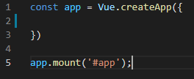

Mount the app to the **div** element with an **id** called **app**.

Look at the example below (**line 15 to 17**).

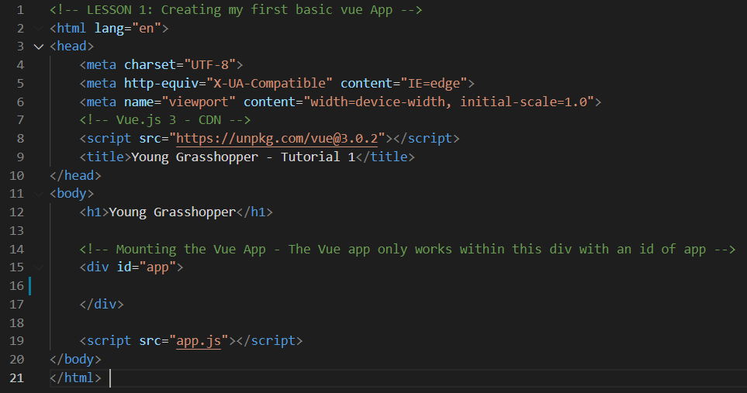

**Step 5:** Create a **template** property that will output the component on the browser.

Look at example below (**Line 2**).

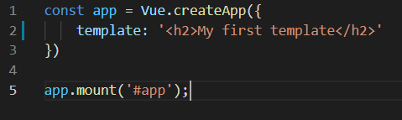

**Output**:

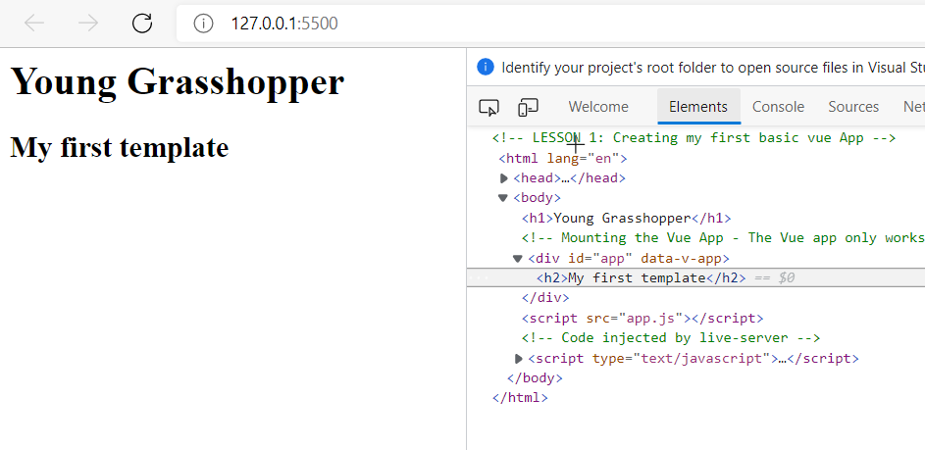

**You can view the code snippets from the** [**vue3-firebase-course**](https://github.com/younggrasshopperza/vue3-firebase-course) **repository under the Tutorial-1 branch.**